**KATALON STUDIO**

**GROUP PRESENTATION**

|  |  |
| --- | --- |
|  | *Group members:*  Bui Dinh Hoang| HE130226  Nguyen Cong Chuc | HE130228  Nguyen Cong Minh | HE130241  Phi Manh Minh | HE130249  *Instructor: Pham Ngoc Ha*  *Courses: SWT301* |
|  |  |

INTRODUCTION

Katalon Studio is an automation testing solution developed by Katalon LLC. It is a comprehensive tool set for web and mobile app automation testing. This tool includes a full package of powerful features that help overcome common challenges in web UI test automation, for example, pop-up, iFrame, and wait-time. This user-friendly and versatile solution help testers test better, work faster, and launch high quality software thank to the intelligence it provides to the entire test automation process. The Katalon Studio is a robust alternative to open source Automation Frameworks. It is easy for beginners to use but offers advanced capabilities for experienced users. This solution is trusted by an active community from 150+ countries around the world.

ABOUT THE SOFTWARE

Katalon Studio provides a dual interchangeable interface for creating test cases: a manual view for the less technical users and a script view gearing toward experienced testers to author automation tests with syntax highlight and intelligent code completion.

Katalon Studio follows the Page Object Model pattern. GUI elements on web, mobile, and desktop apps can be captured using the recording utility and stored into the Object Repository, which is accessible and reusable across different test cases.

Test cases can be structured using test suites with environment variables. Test execution can be parameterized and parallelized using profiles.

Remote execution in Katalon Studio can be triggered by CI systems via Docker container or command line interface (CLI).

TECHNOLOGIES

The test automation framework provided within Katalon Studio was developed with the keyword-driven approach as the primary test authoring method with data-driven functionality for test execution.

The user interface is a complete integrated development environment (IDE) implemented on Eclipse rich client platform (RCP).

The keyword libraries are a composition of common actions for web, API, and mobile testings. External libraries written in Java can be imported into a project to be used as native functions.

The main programming language used in Katalon Studio are Groovy and Java. Katalon Studio supports cross-environment test executions based on Selenium and Appium.

**Supported technologies:**

* Modern web technologies: HTML, HTML5, JavaScript, Ajax, Angular
* Windows desktop apps platforms: Universal Windows Platform (UWP), Windows Forms (WinForms), Windows Presentation Foundation (WPF), and Classic Windows (Win32)
* Cross-browser testing: Firefox, Chrome, Microsoft Edge, Internet Explorer (9,10,11), Safari, headless browsers
* Mobile apps: Android and iOS (Native apps and mobile web apps)
* Web services: RESTful and SOAP

**System requirements:**

Operating systems: Windows 7, Windows 8, Windows 10, macOS 10.11 , Linux (Ubuntu-based)

LICENSE

Katalon Studio started out as Freeware with business support services. Katalon LLC also provides premium support and training customizations and testing services using the based software.

In October 2019, Katalon introduced a new product set with proprietary licenses in its seventh release. The new products and licenses include, including Katalon Studio, Katalon Studio Enterprise, and Katalon Runtime Engine, so that teams and projects of various complexities can have a flexible allocation on budget, licensing, and scalability.

RELEVANT PRODUCTS

**Katalon TestOps**

Katalon TestOps is a web-based application that provides visualized test data and execution results through charts, graphs, and reports. Its key features include execution grid, advanced reports, monitoring and alert, and AI analytics. Katalon TestOps can be integrated with Jira and other CI/CD tools.

Katalon TestOps was originally released as Katalon Analytics in November 2017. In October 2019, Katalon officially changed the name to Katalon TestOps. It is currently available in beta version.

**Katalon Recorder**

Katalon Recorder is a browser add-on for recording user's actions in web applications and generating test scripts. Katalon Recorder supports both Chrome and Firefox. Katalon Recorder functions in the same way as Katalon Studio's recording utility, but it can also execute test steps and export test scripts in many languages such as C#, Java, and Python.

**Katalium**

Katalium is a framework that provides a blueprint for test automation projects based on Selenium and TestNG. The framework is built to help users who still need to work with TestNG and Selenium to quickly set up test cases.

Katalium Server is a component of the Katalium framework. It is a set of enhancements to improve the user experience with Selenium Grid. Katalium Server can be run as a Standalone (single) server in development mode.

Both Katalium Framework and Katalium Server are made open-source.

KEY FUNCTIONS OF KATALON STUDIO

* **Simple deployment:** A single, cohesive deployment package contains everything you need to deploy a powerful test automation tool
* **Quick & easy set-up:** Not only providing simple installation, Katalon Studio also makes its easy to set up the environment. testers can run their first test script quite quickly using its pre-built templates and test scripts, such as object repositories and keyword libraries.
* **Faster & Better results:** Built-in templates with clear tutorials help testers quickly build and run the automation test scripts. They can perform every single step with speed and efficiency, from project setup, test creation, execution, report generating, and maintenance.
* **Flexible modes:** New testers can use recording and keywords to build automation tests, while expert testers have a full IDE to build advanced scripts.
* **Ease of use:** It couldn’t be easier, even manual with minimum programming experience can also exploit its benefits with effortlessly.
* **Multi-OS application:** Katalon Studio supports multiple platforms: Windows 32 and 64 (7, 8, and 10) and OS X 10.5+.

HANDS-ON WITH KATALON STUDIO

Katalon Studio is an insightful, user-friendly automation solution that is characterized by the simplicity and speed. It is helpful for automation tester teams and individuals to spend the least efforts from setting up a new project to executing tests and then monitoring execution results. Each workflow provides lots of capabilities and customizations for effortless maintenance and project scale up:

* Pre-defined structure of test artifacts: test cases, test suites, test objects, reports. Testers no longer need to spend hours in defining and maintaining them later.
* Custom keywords provides the flexibility in adding additional keywords to test the AUT efficiently for the specific and complex testing purposes.
* Support major testing needs: Web, Mobile and API.
* Execute multiple test suites at once with test suite collection.
* Extend current CI flow easily with console mode execution at no efforts. Executing command line can be generated quickly using ‘Generate Command Line for console mode’ feature.
* Monitor execution results easily with either Table view or Tree view during / after execution.
* Detailed Test Suite report reducing time in analyzing results. You can export it to different format such as CSV, PDF, HTML and store it for later use.

KATALON STUDIO WORKFLOW:

NAVIGATING A LINEAR, STREAMLINED WORKFLOW WITH KATALON STUDIO:

**Initiate**

* Integral project templates: by offering built-in templates for organizing test cases, object repository and keywords, Katalon Studio makes testing easier for testers than ever before.
* Multiple capabilities: Fully supports Web, Android, iOS and API testing on all operating systems.
* Hassle-free tool integration: Easy to integrate with Jenkins, GIT and JIRA with native plug-ins.

**Create**

* Automatic test generation: Records actions and generates scripts automatically using built-in keywords.
* Hi-end scripting: Enables building advanced test scripts or customizable keywords with ease and efficiency.
* Smart object capturing: An advanced recorder detects object properties effectively to maximize recognition.

**Operate**

* Test execution made powerful: Runs test cases or test suites using multiple configurations and data sets.
* Versatility in execution: Provides CI integration console with various parameters for remote execution. Runs tests on multiple browsers and OS’s locally or with Sauce Labs and BrowserStack.
* Flexible failure handling and auto re-execution: Includes run-time rules to automatically handle complex execution flows.

**Report**

* Reports available in several formats: With advanced logging, debug data and screenshots.
* Bespoke execution reports: Integrated with your notification workflow.
* Enhanced Selenium and Appium logs: With improved analysis features to improve automation strategy.

**Maintain**

* Intelligent test object maintenance: Automatically updates all associated test cases and suites when objects are changed.
* Efficient test organization: Allows easy management and maintenance of tests, data and keywords.
* Easy team collaboration: Integrates with GIT to allow team members to easily share artifacts and workload.

LEARN MORE ABOUT FUNCTIONS OF KATALON STUDIO

* **Technology skills:** Katalon Studio enables automation of the most common functions of web applications and mobile applications without coding experience. This tool allows people to automate easily and effectively by taking advantage of the integrated features, even you can start automating the application from the first sprint run.
* **Record and run on popular browsers and mobile applications:** Studio Katalon utility supports recording and running similar tests on many browsers. In addition, Katalon Studio is very smart to handle dynamic web elements by modifying test object properties using built-in methods (Add / Remove Object Property) at run time.
* **Page-Object Model Framework:** Katalon Studio allows users to streamline the collection process to store and manage page objects using project structure and then organize them in specific layers to reuse it later.
* **Rich report frames:** Katalon Studio easily creates HTML, CSV or PDF reports that provide an overview of how our automated testing efforts are progressing by connecting screenshots and logs.

USER MANUAL

1. **Download the application**

Access homepage of Katalon [https://www.katalon.com/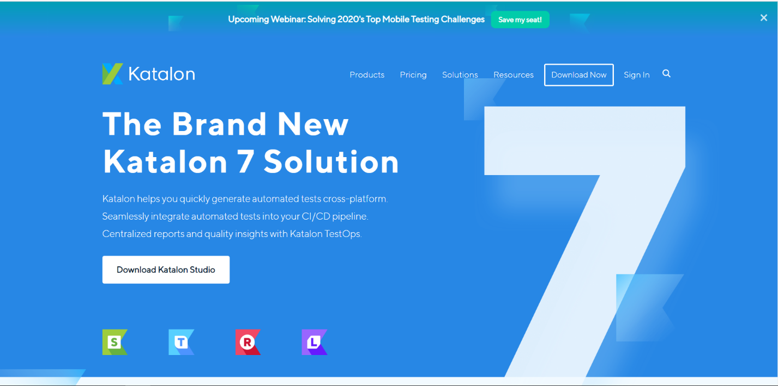](https://www.katalon.com/)

Then click “Download Now” to get file .rar of Katalon

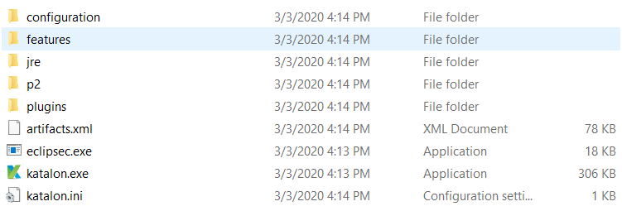Extract and open “katalon.exe” to run Katalon

1. **Create project test web local on Katalon**

* Click Test Cases -> New -> Test case. Name the test file then click OK

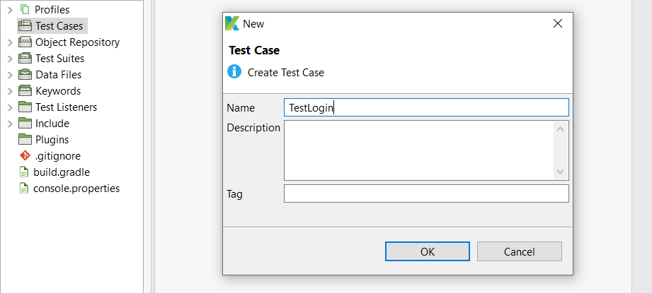

* Then click  and fill the URL which you want to test 

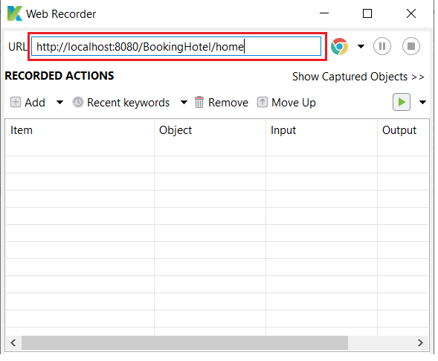

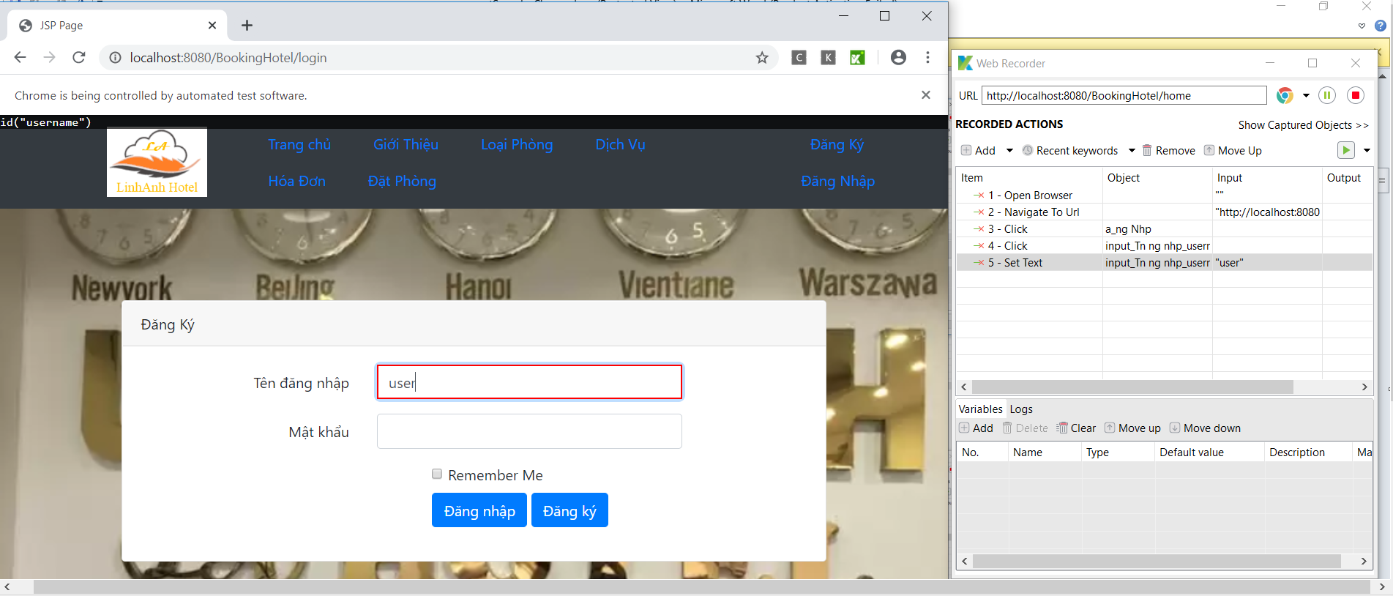

* You perform the operation from the beginning to the end that you want Katalon to automatically test and click OK to save

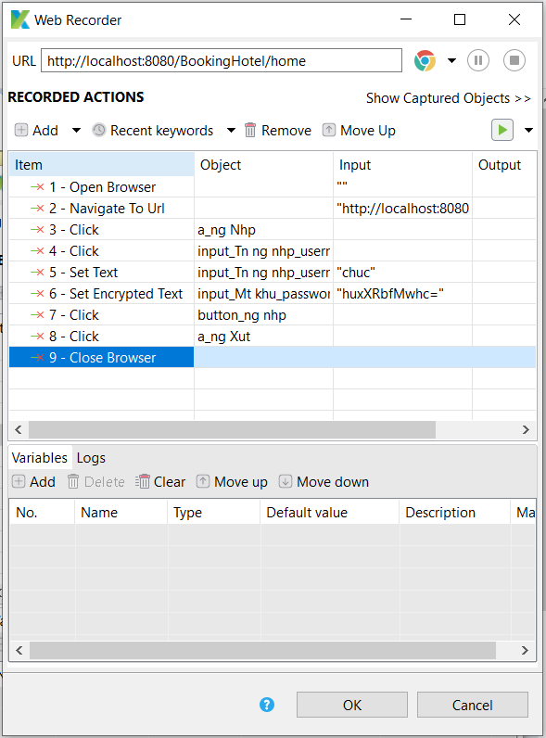

* You will get a file of test operations in katalon. 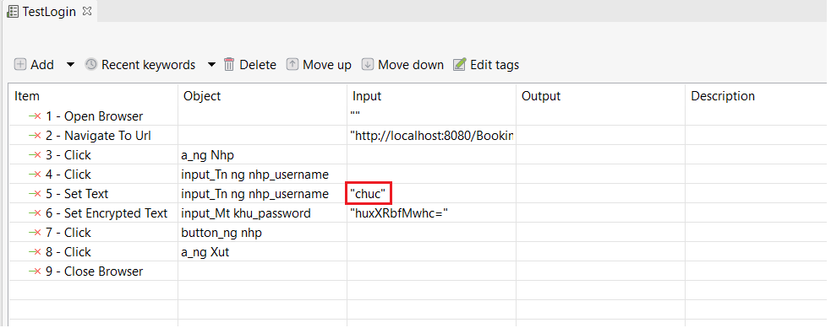
* You can change the value of the function to pass excel data according to the variables and convert Value Type to Variable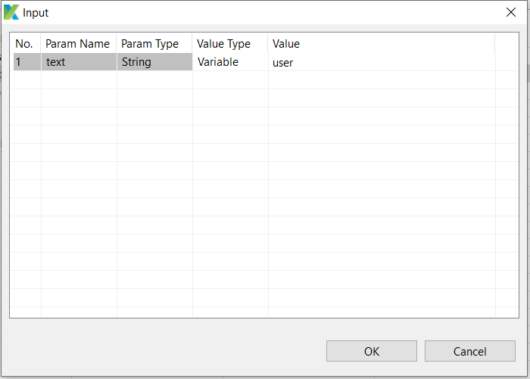
* Or you can change variables as you like in the Script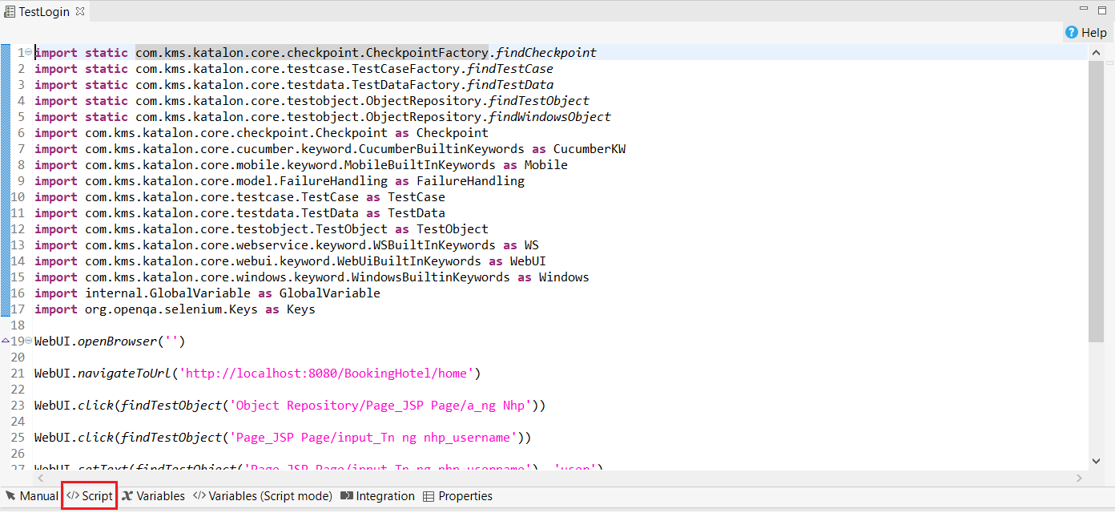
* Select Variables -> Add to declare the parameters you want to pass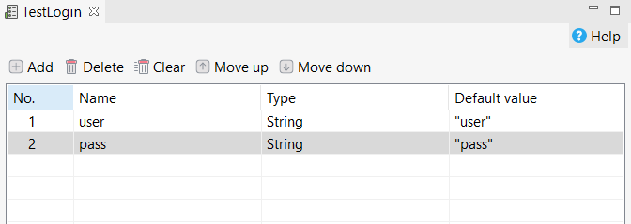
* Then select Data Files -> New -> Test Data to create the Test data file and select OK

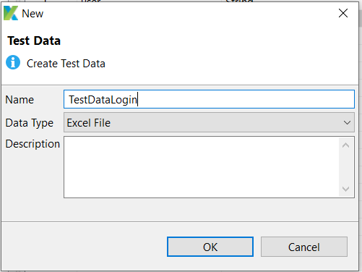

* Create an excel file containing the data you want to pass during the test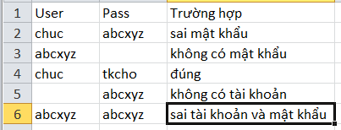
* Open the Data test file and select Browse to where to save the excel file to upload the data in the excel file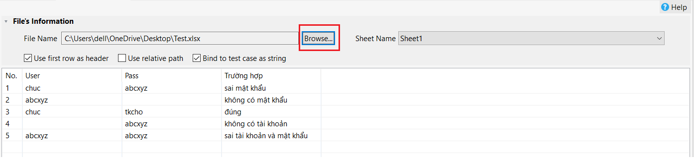
* Select Test Suites-> New-> Test Suite, name the test suite file and select OK. To select test case and select data file

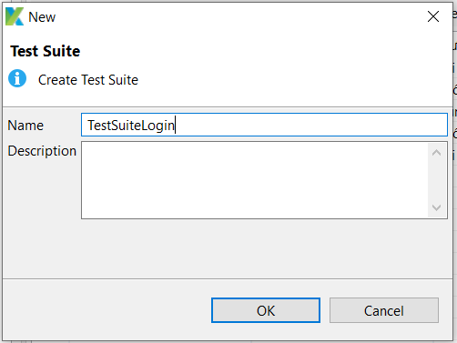

* Select  to open all the data files to use

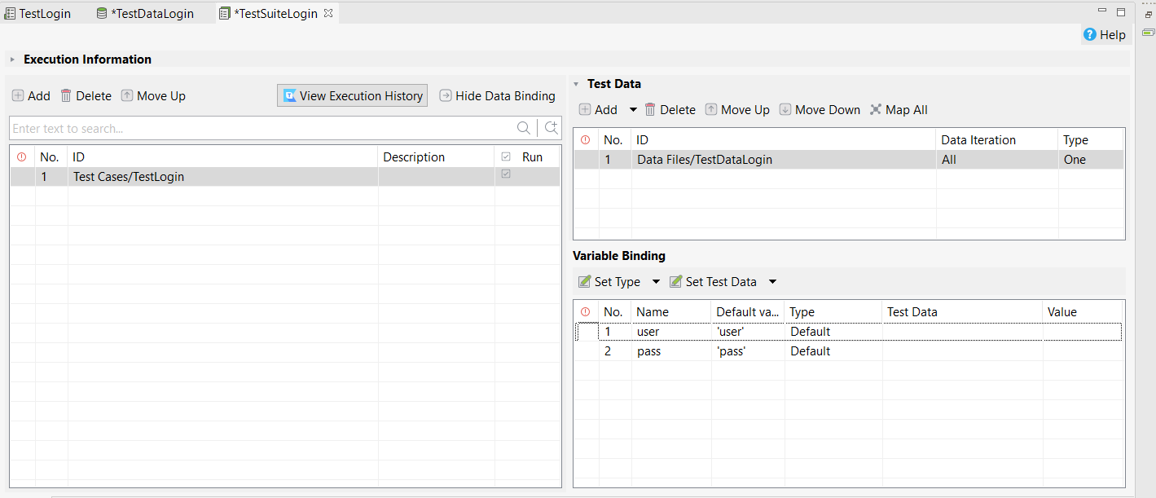

* Click 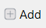 to add a Test file

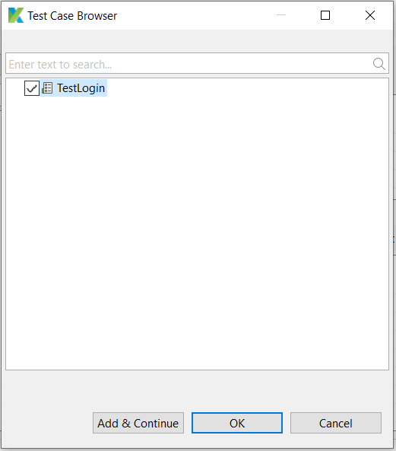

* Click 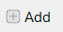 to add Test data file 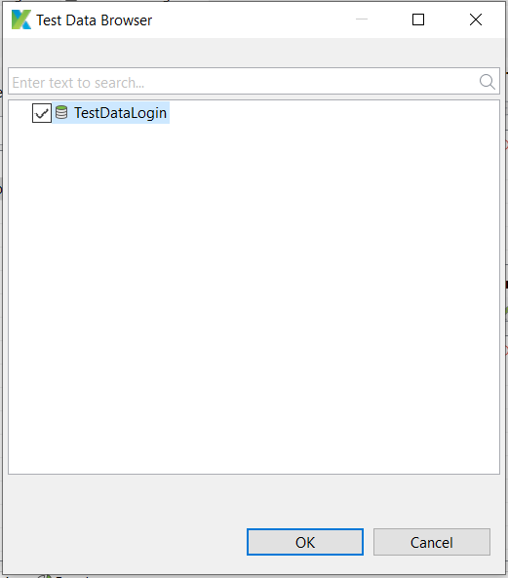
* Select Set Type-> Data Column to get data by columns in excel file

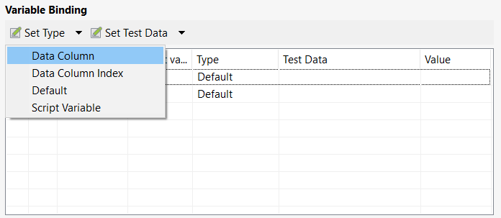

* Select the data fields expected to be transferred

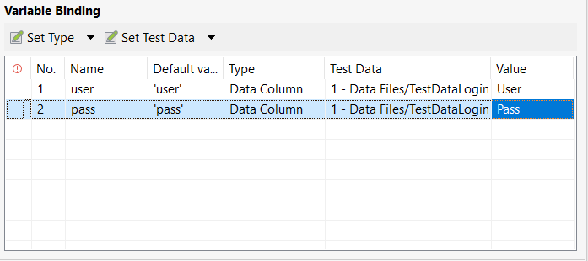

* Select  to run the test automatically

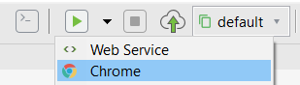

SAMPLE: TEST AUTOMATIC WEBSITE WITH KATALON (TAKE DATA FROM FILE EXCEL)

* Create project test web

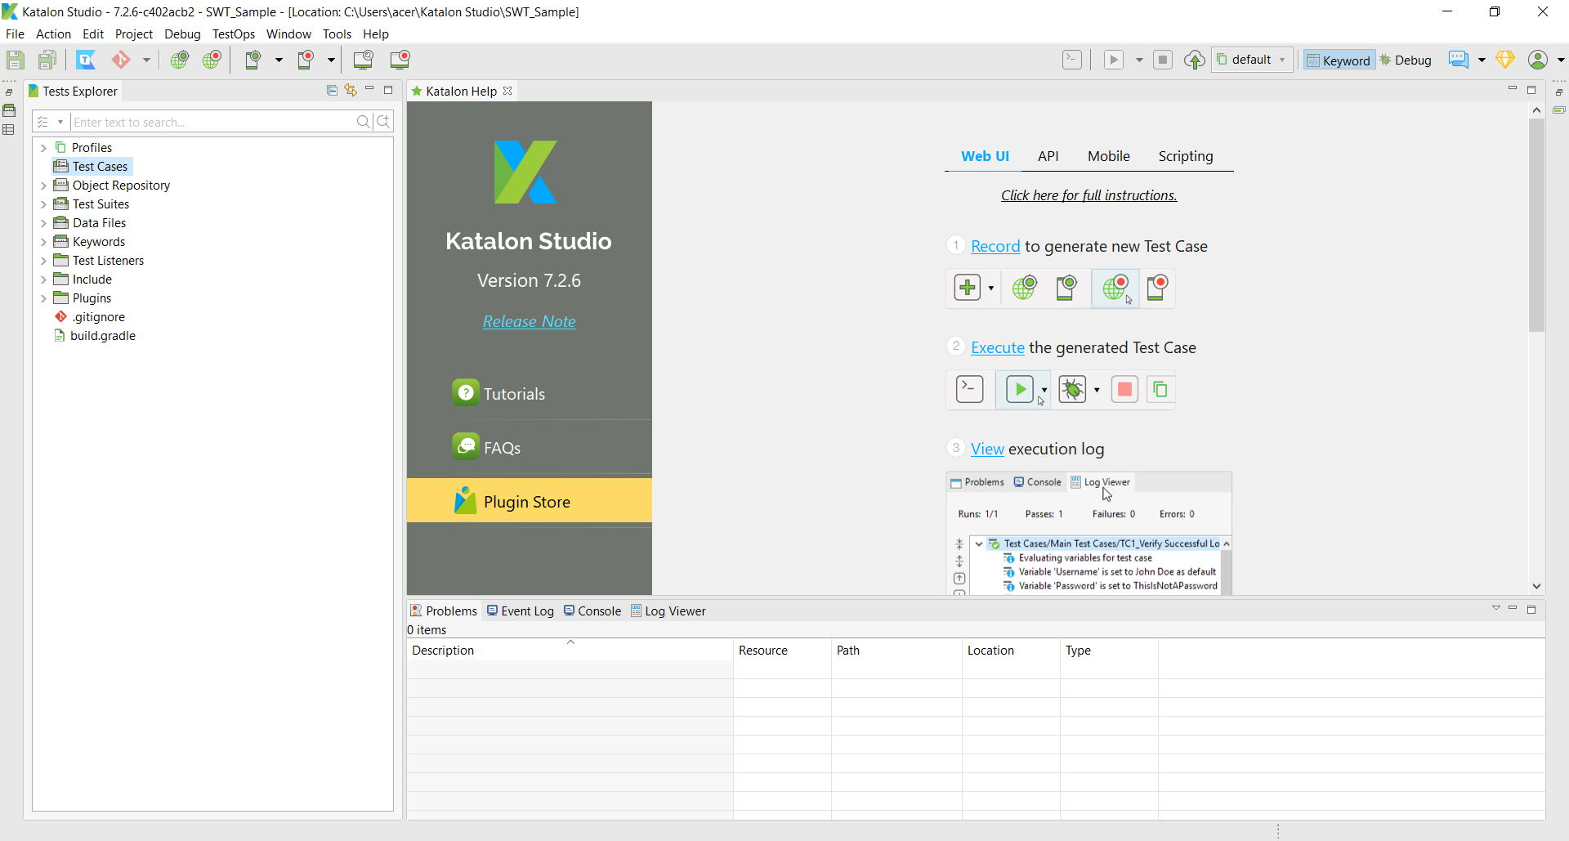

* Create test case

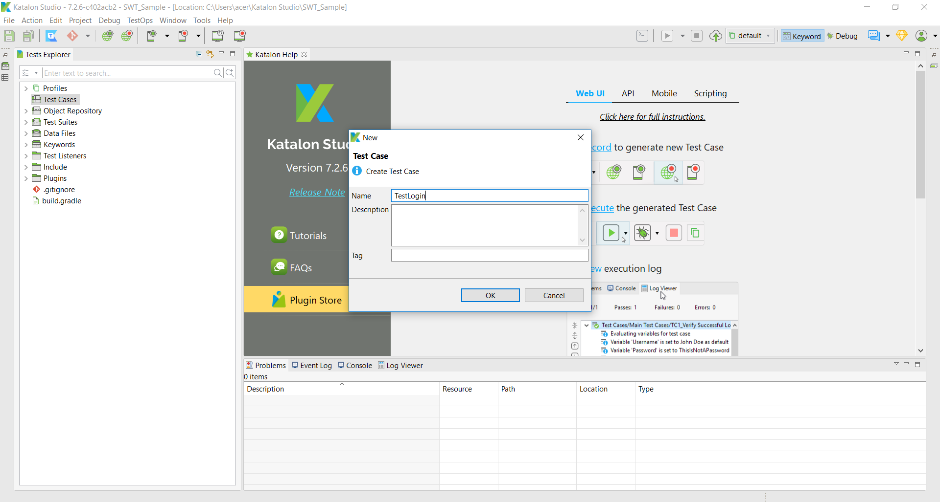

* Choose Web Recorder and input link website to test automating

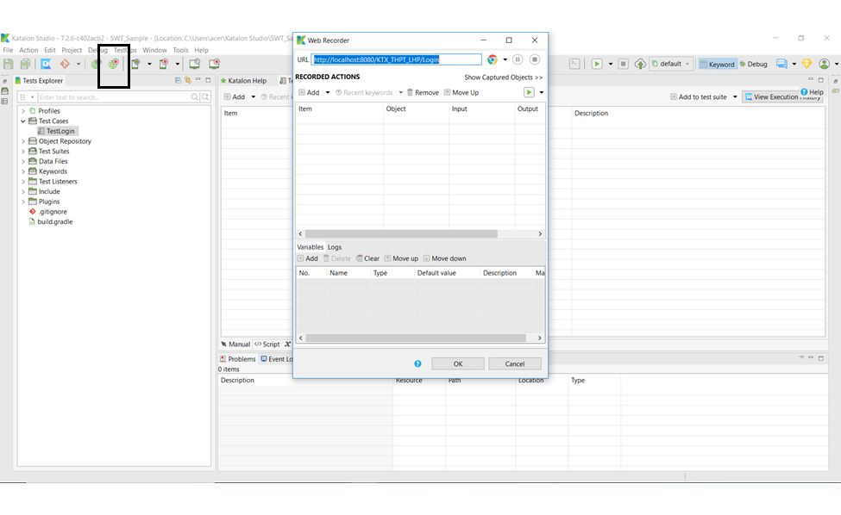

* Katalon automatically open the page
* Select the test functions in order(click button login => input username =>input password => click Login => click đăng xuất => close web Browser)

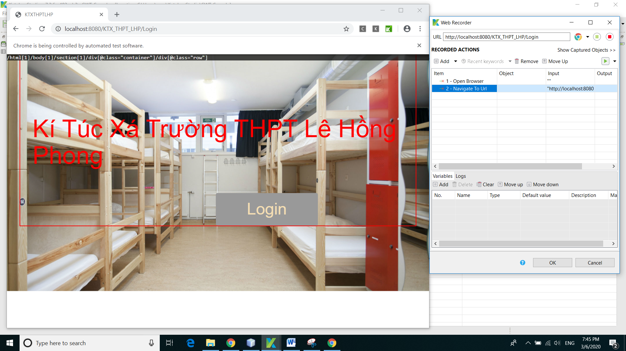

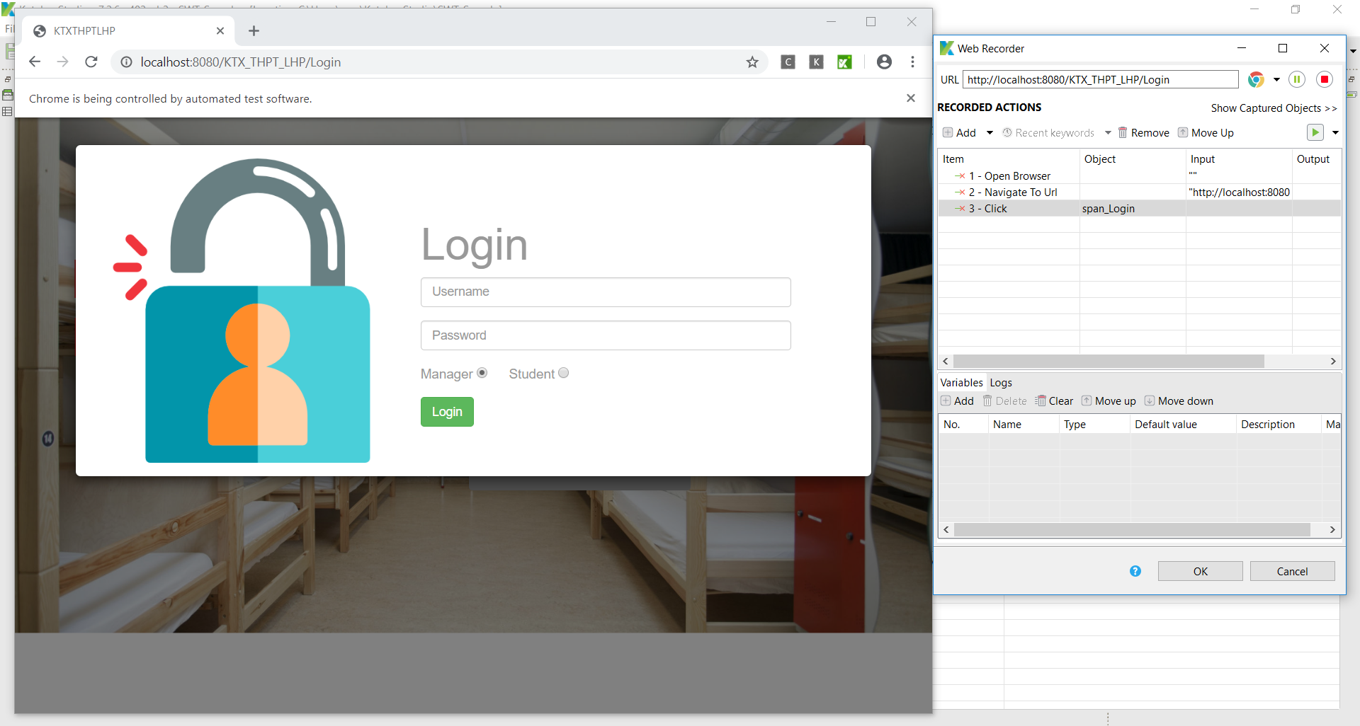

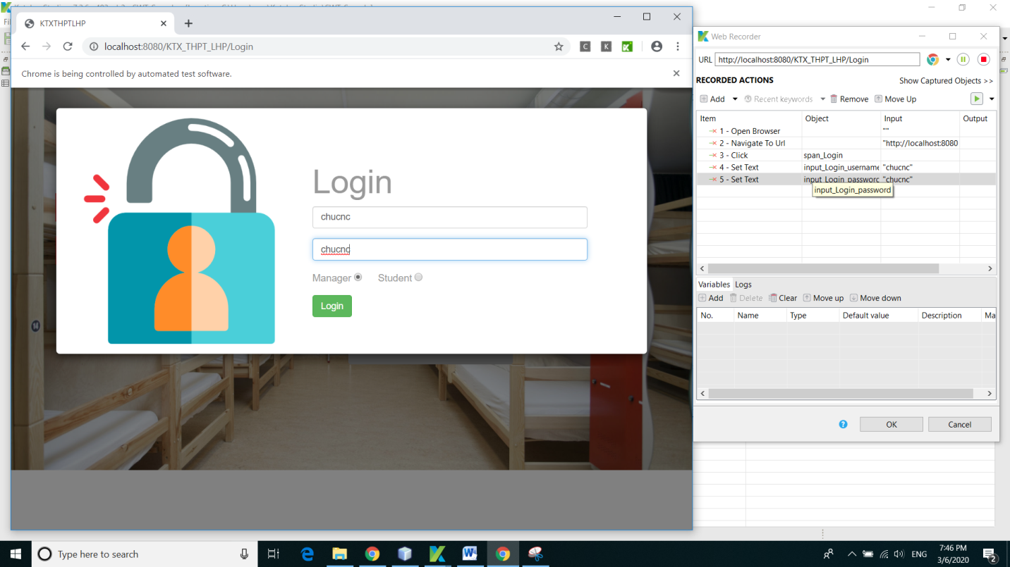

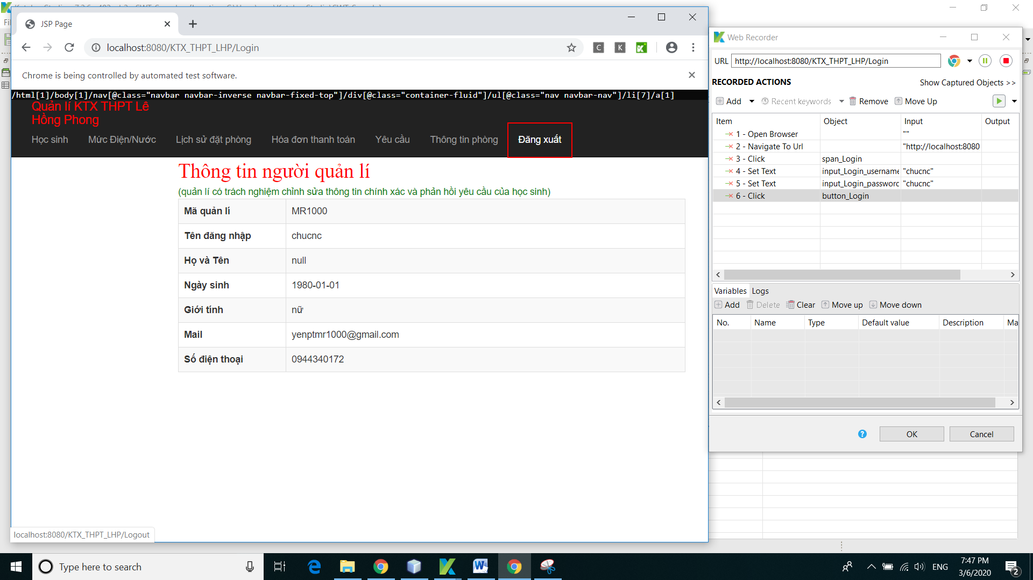

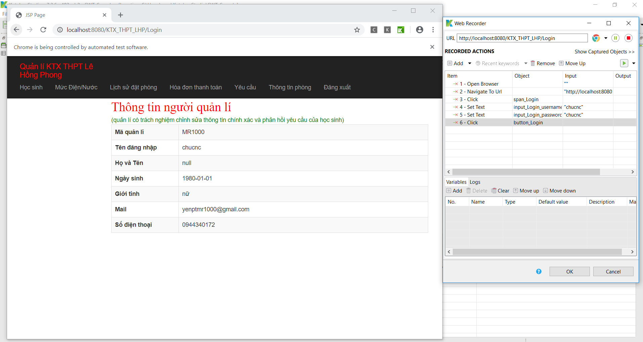

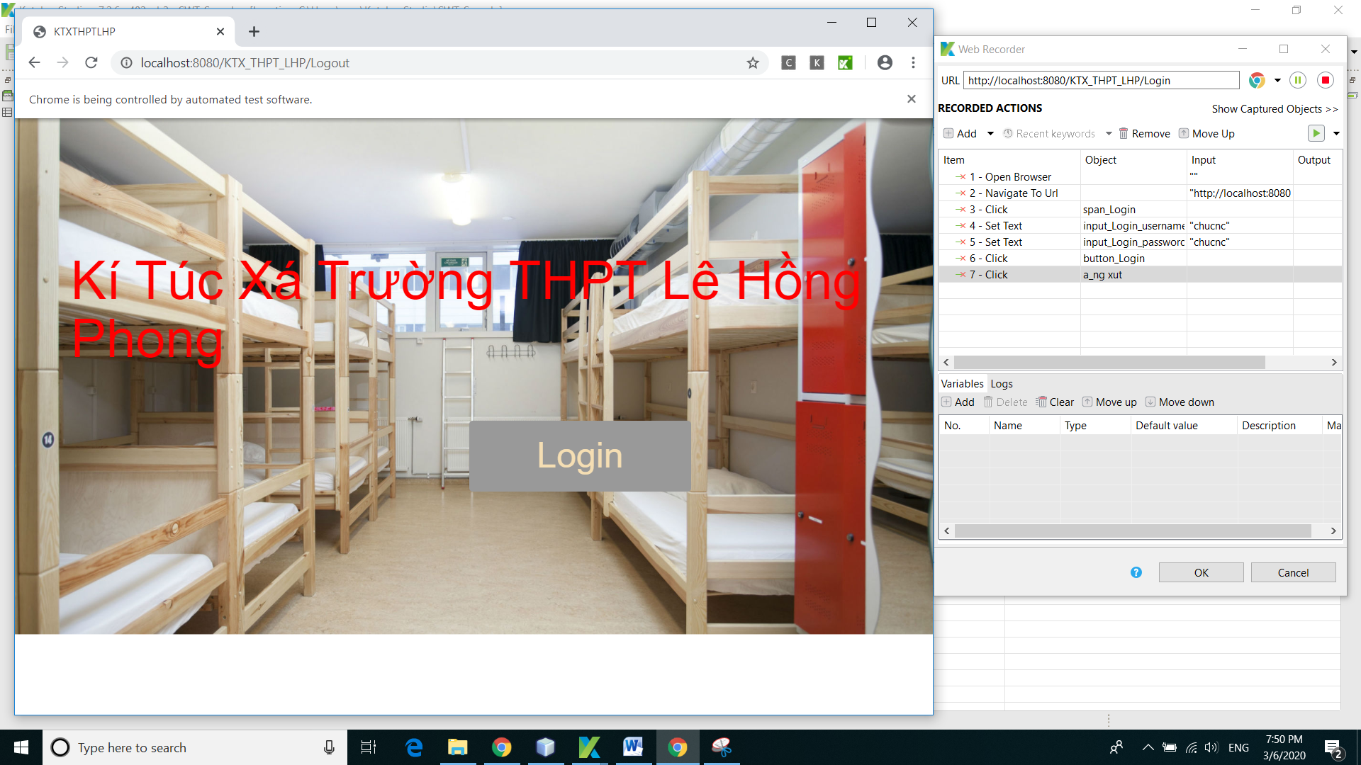

* Save all functions that need to be tested by pressing the button “ok”

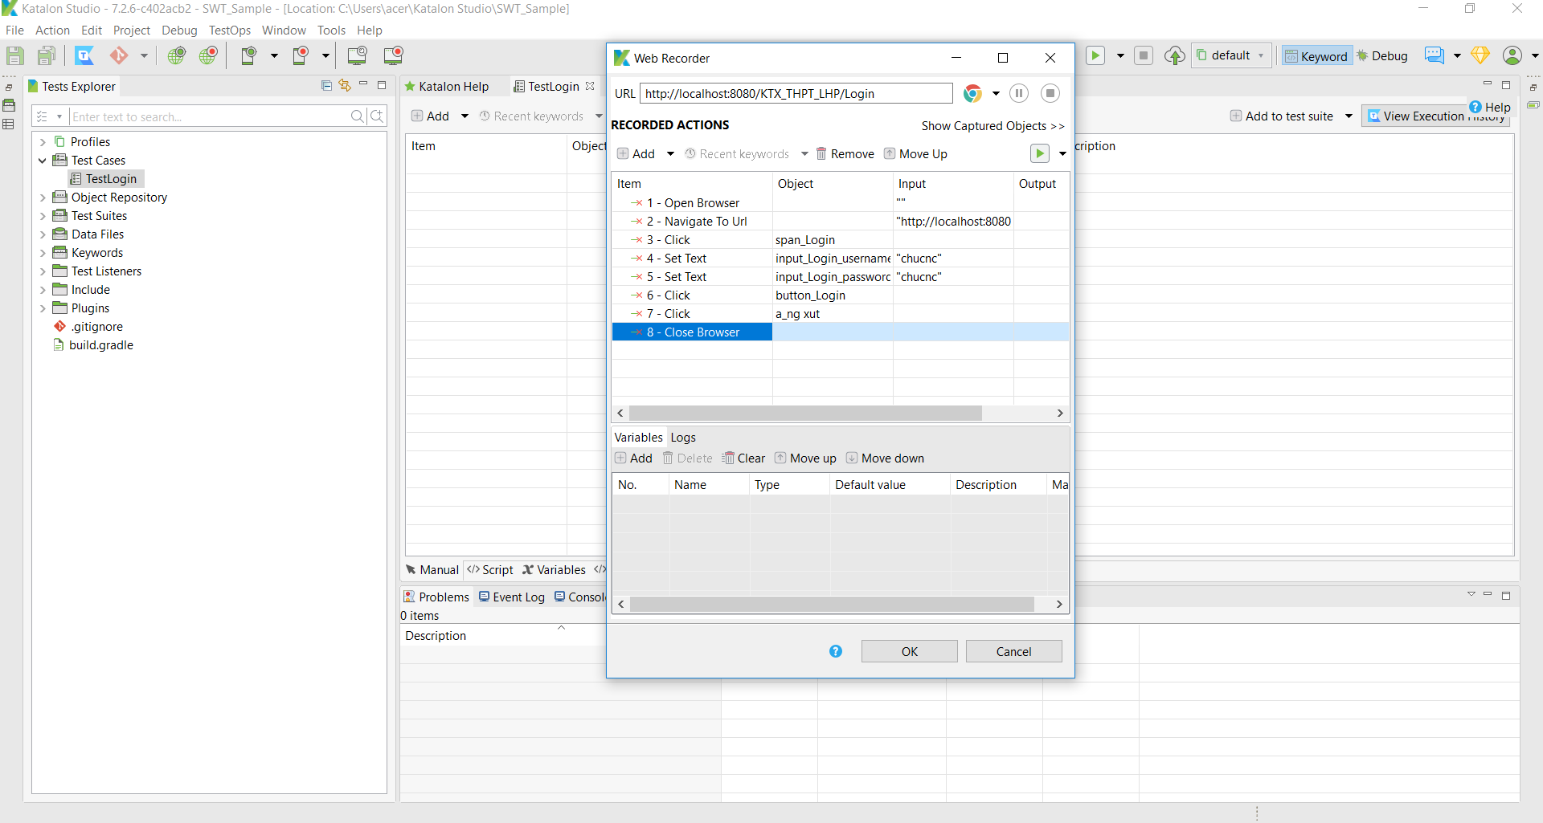

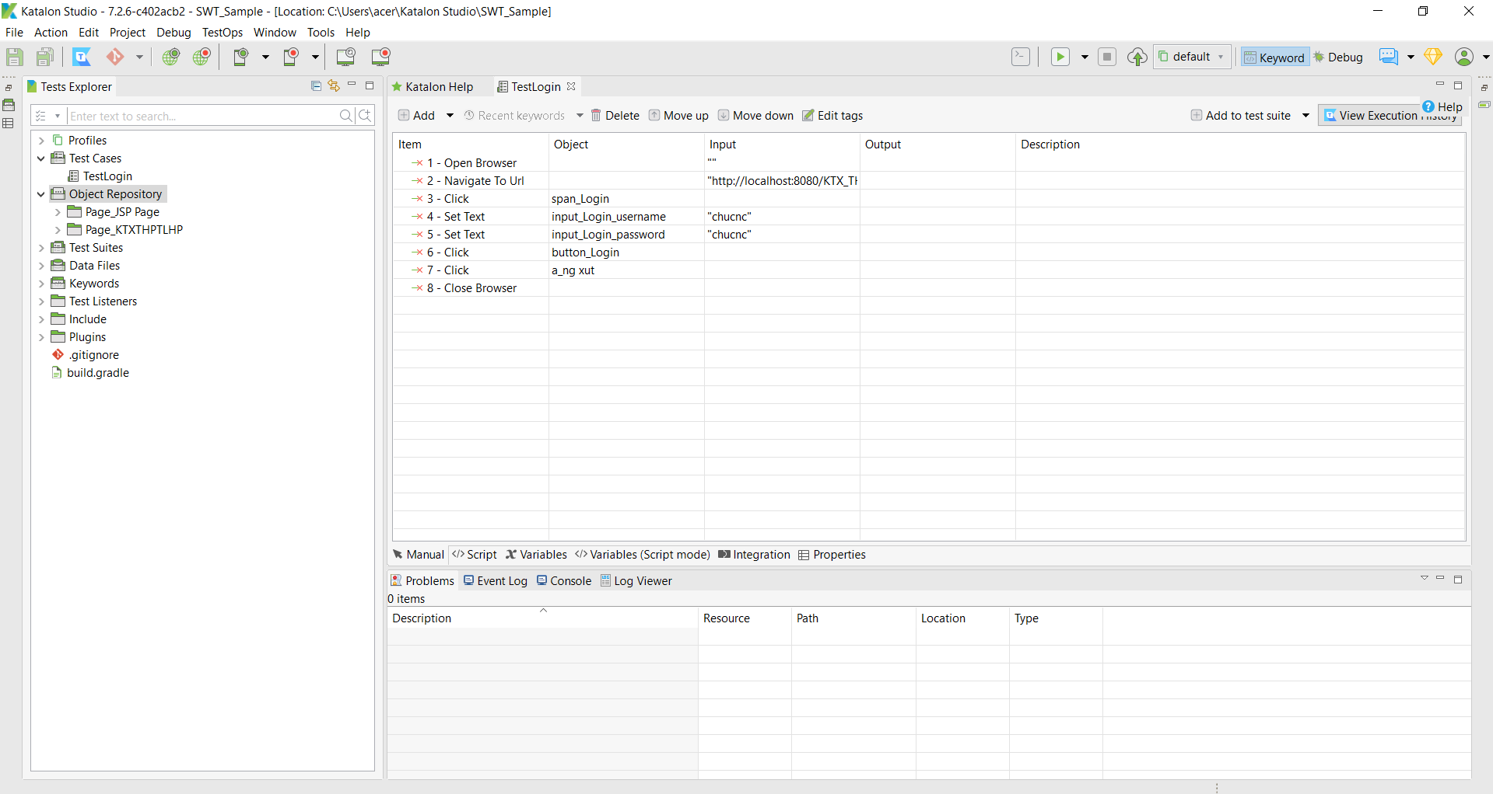

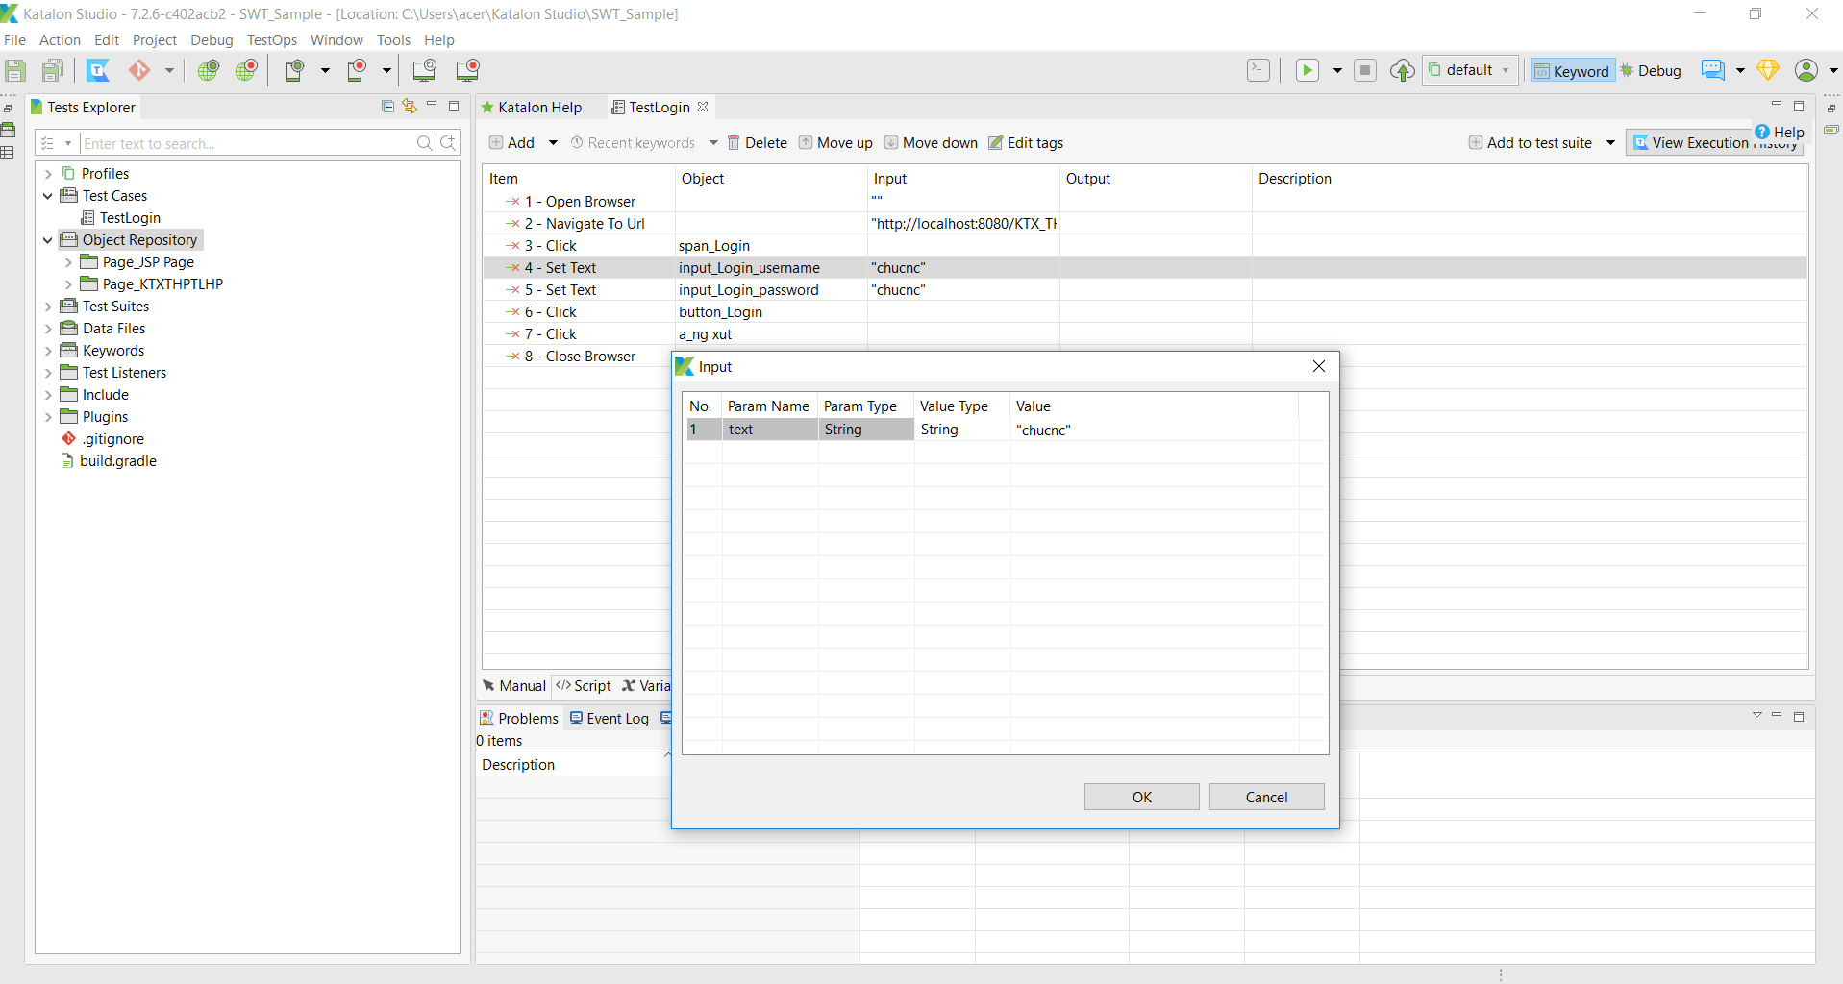

* Edit functions to transfer data from excel by variables(variable user-username & pass-password)

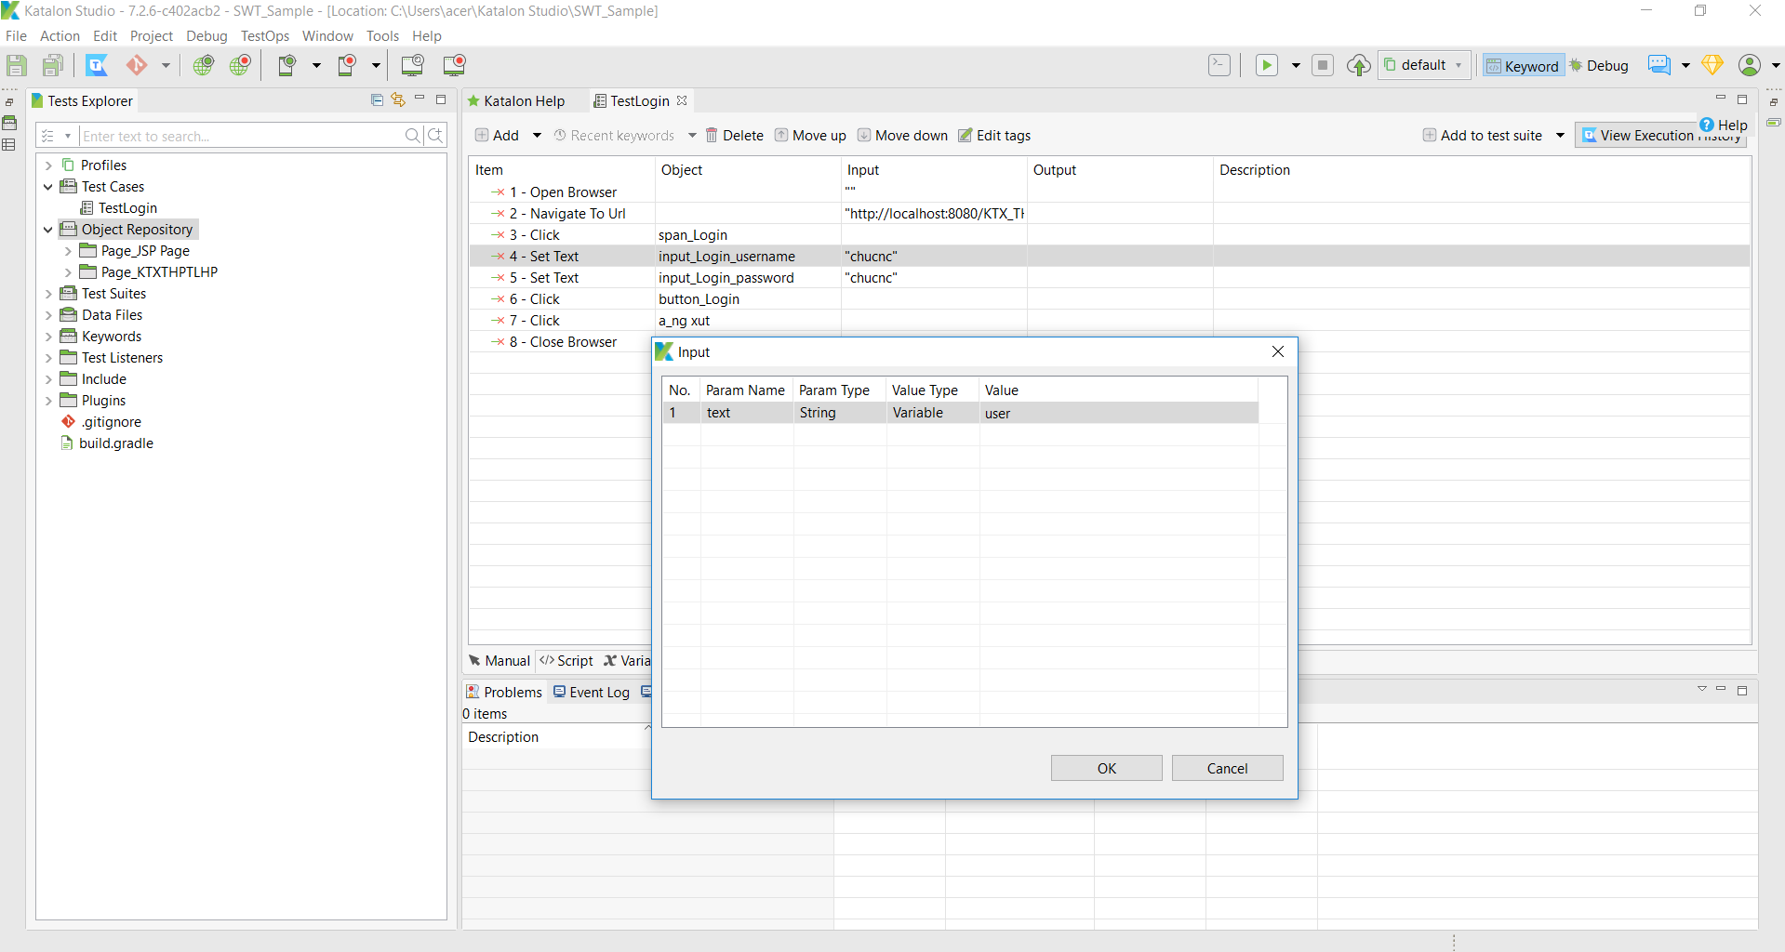

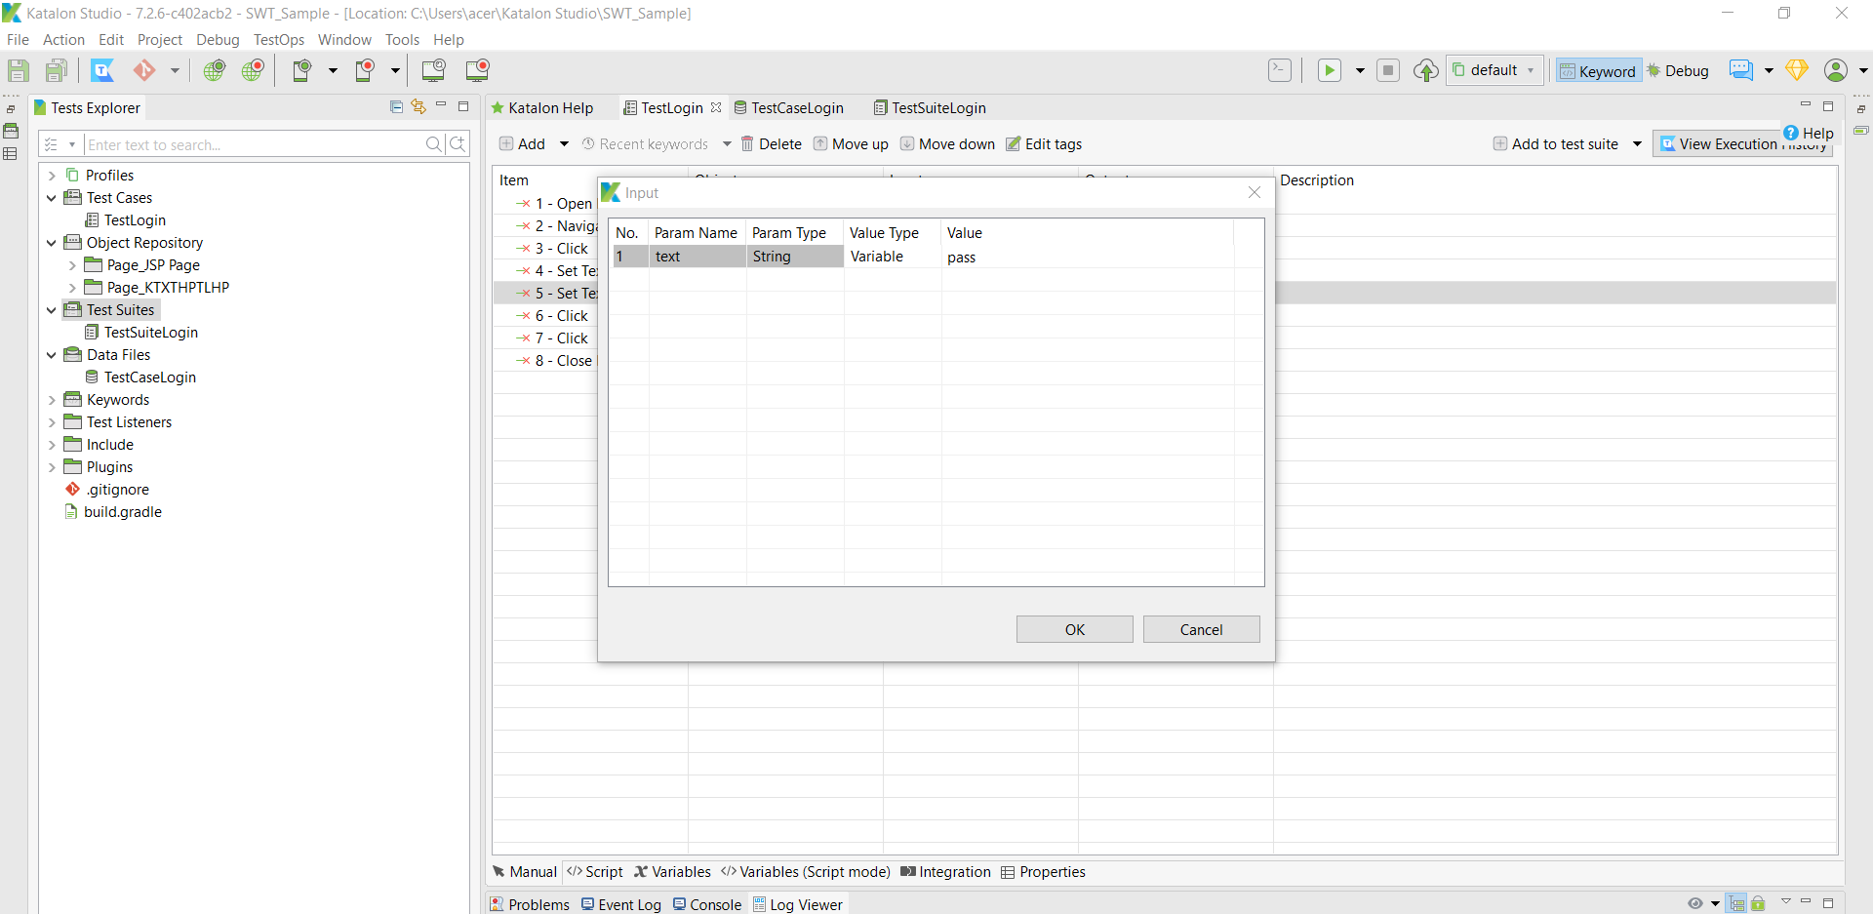

* Scripts of functions

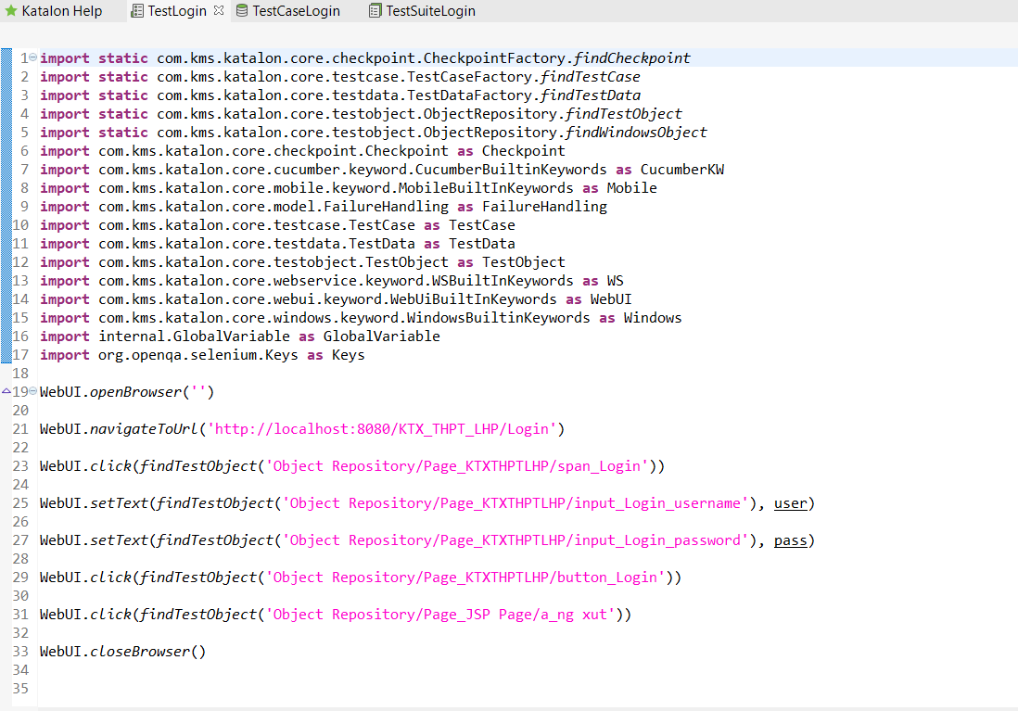

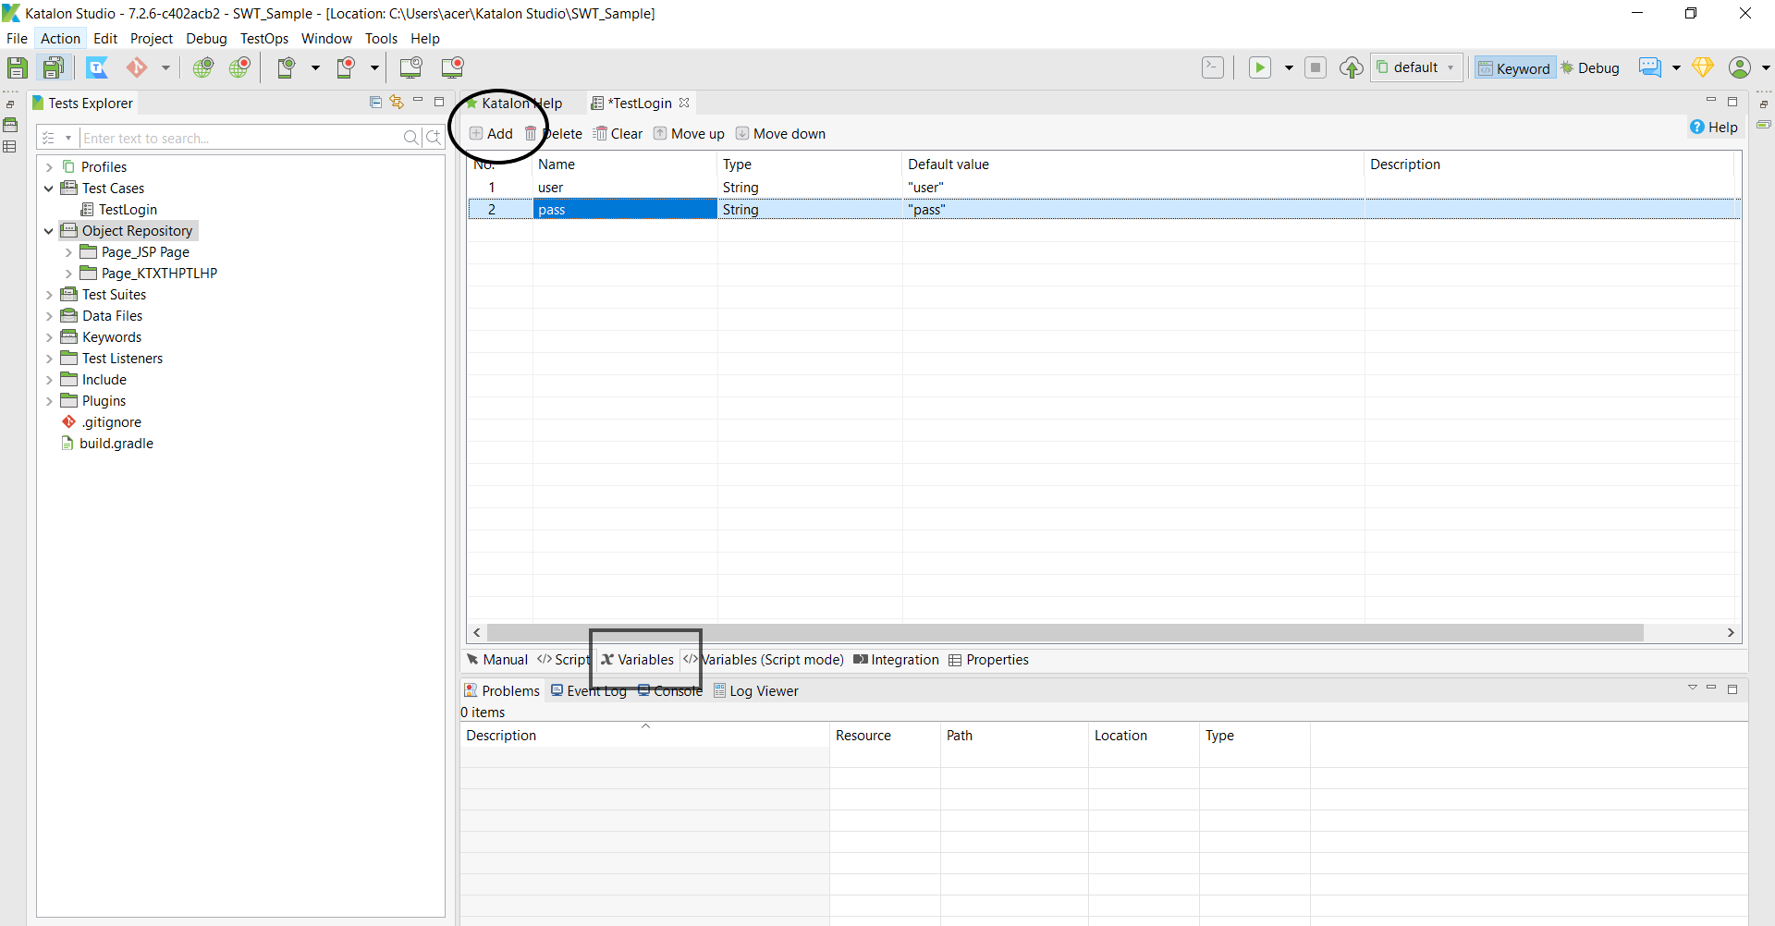

* Create Data file(excel)

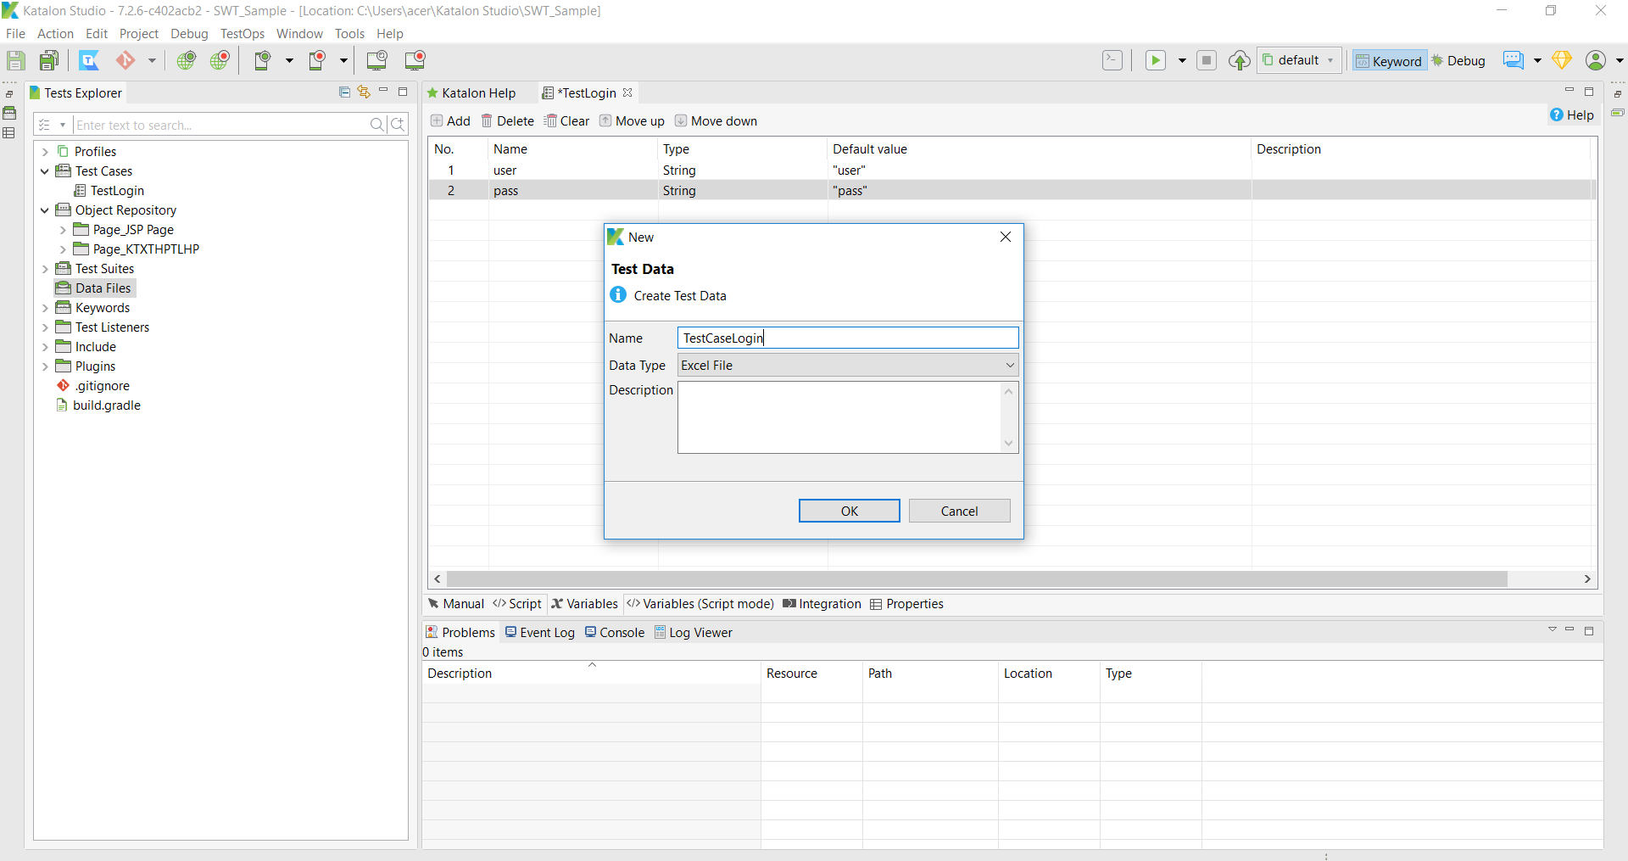

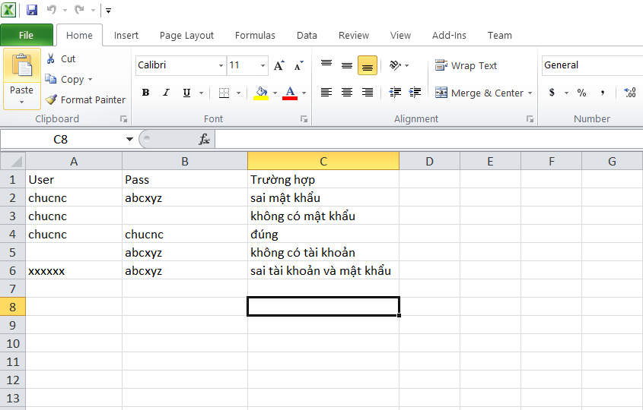

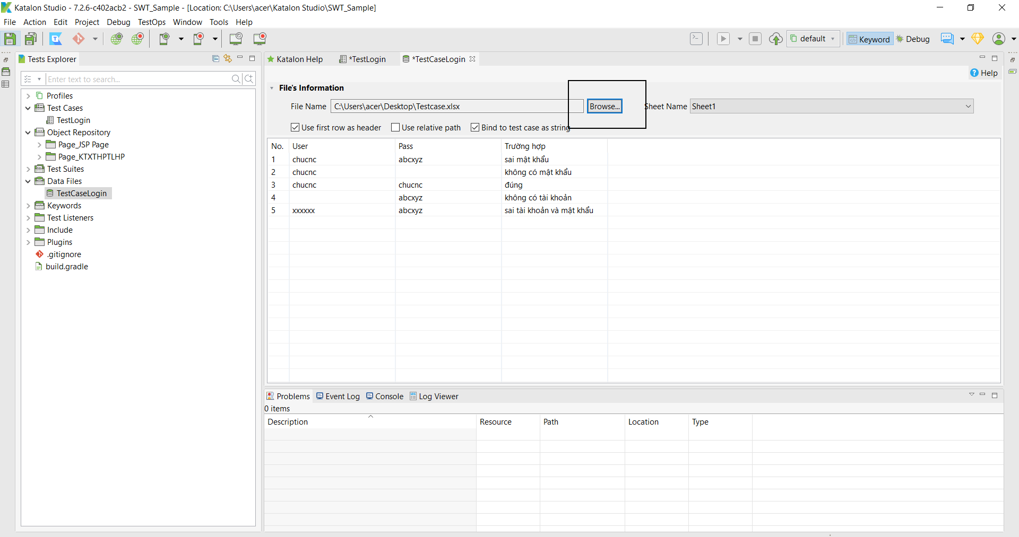

* Create test suite

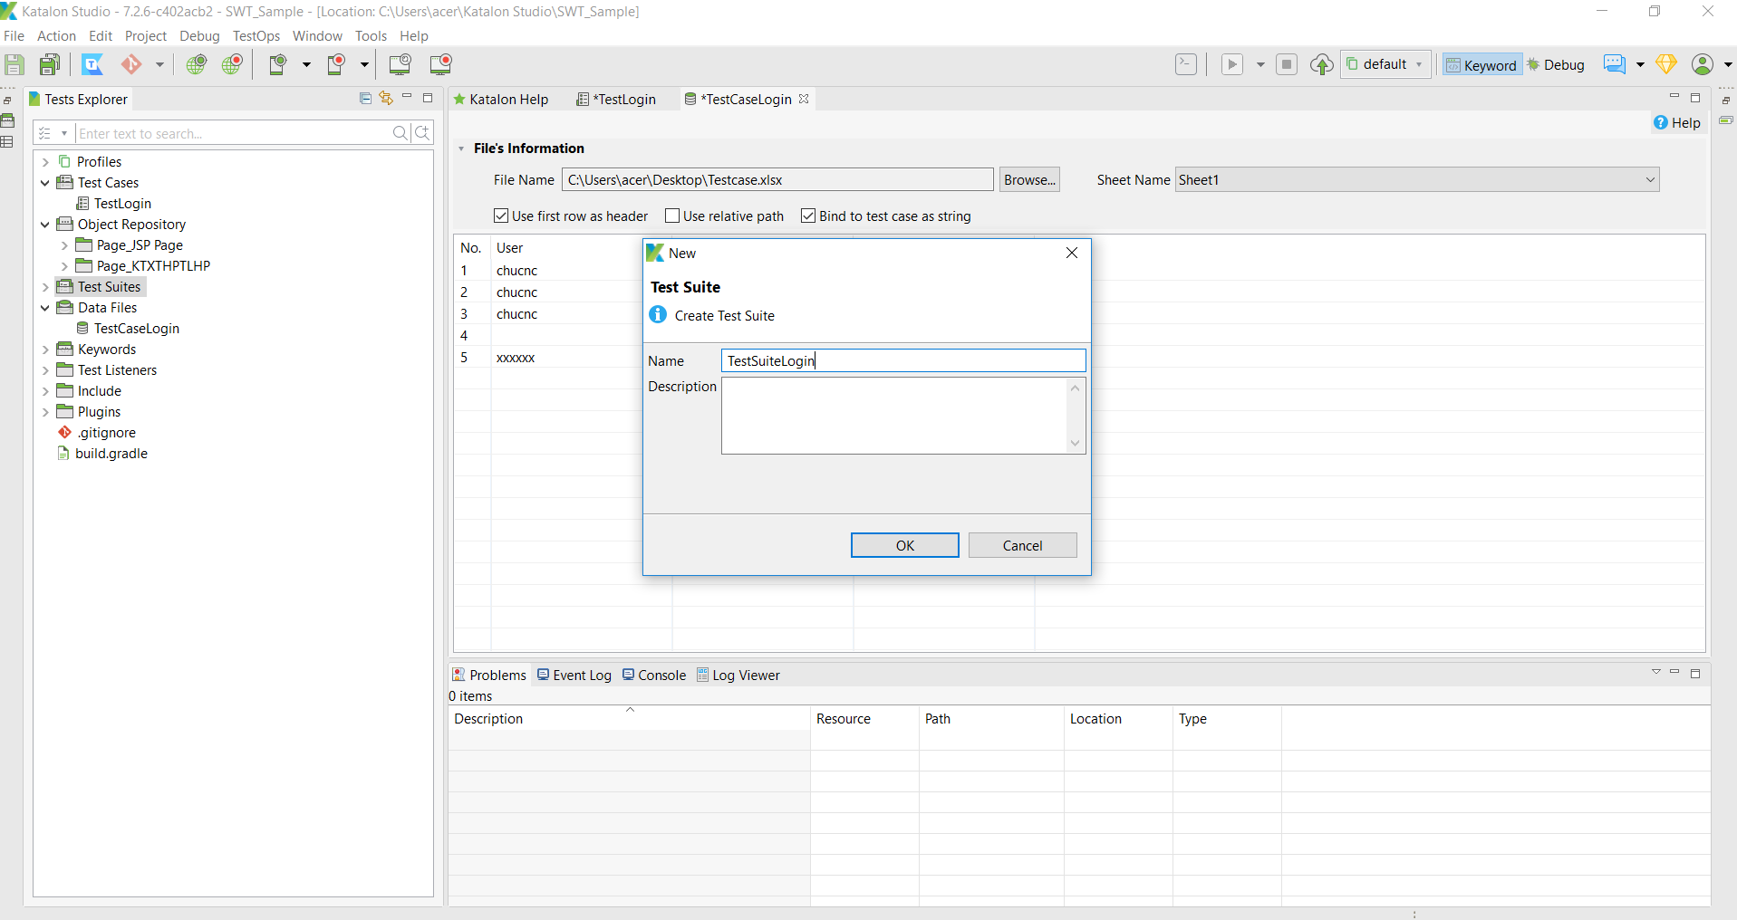

* Select Test Case to test

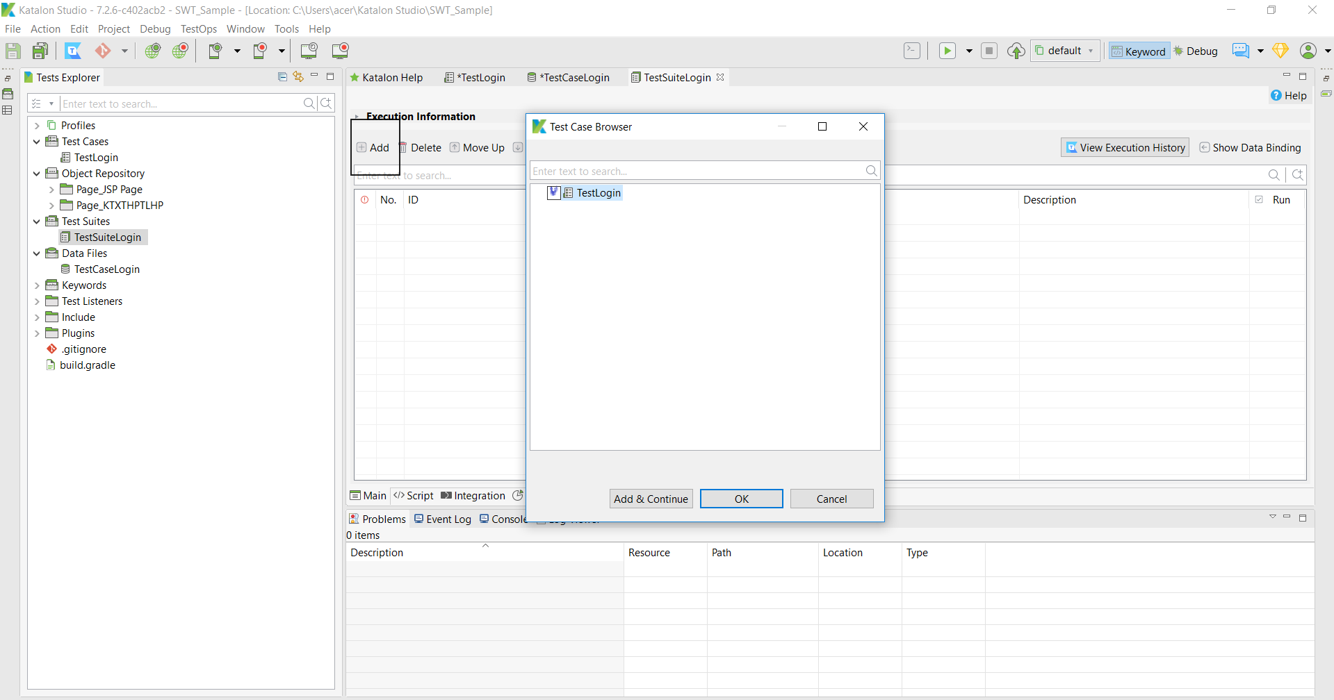

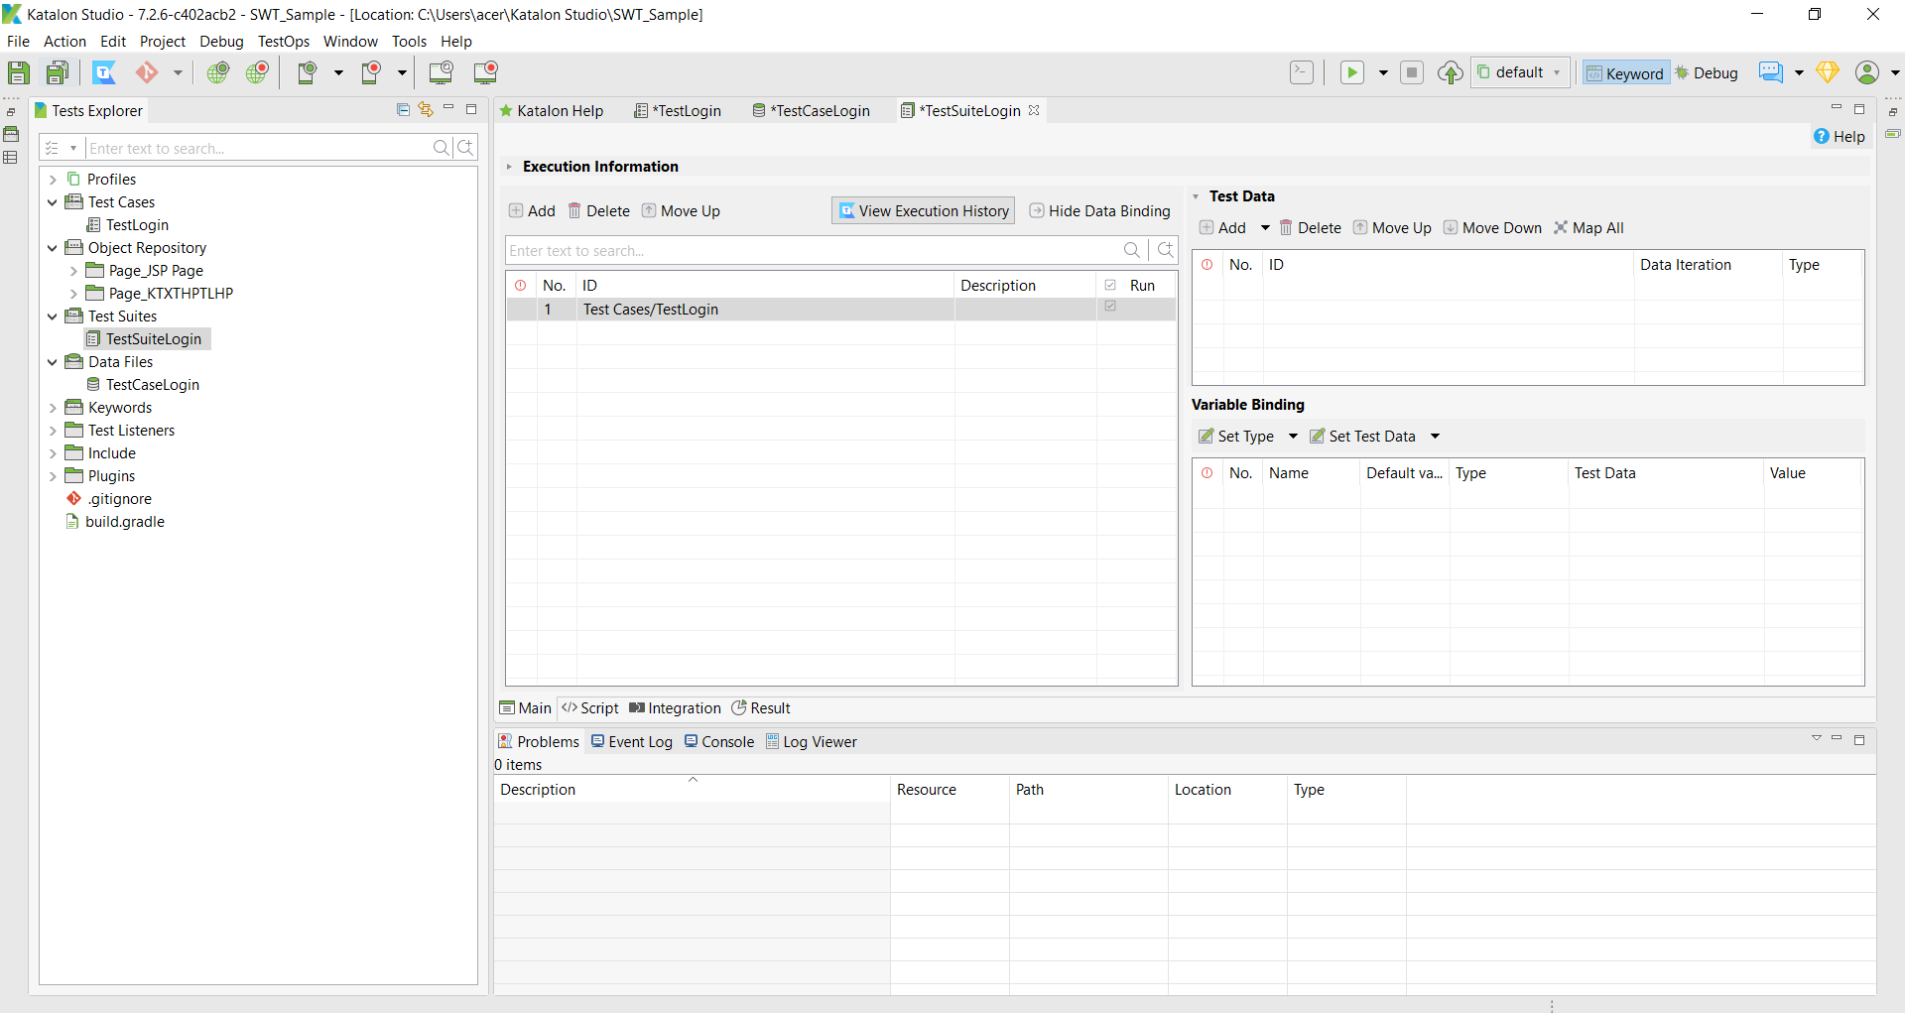

* Choose DataFile for TestCase

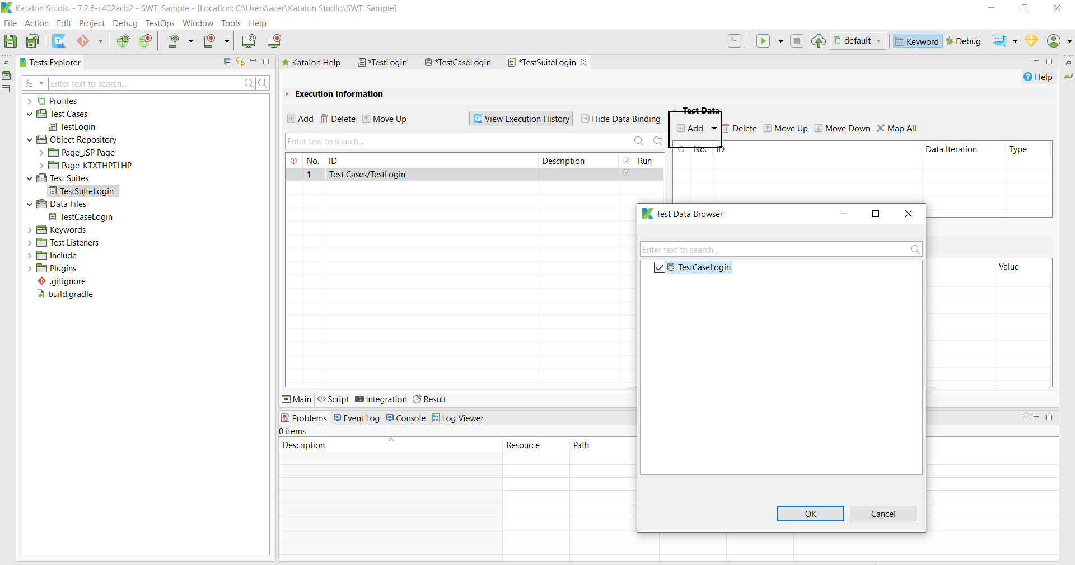

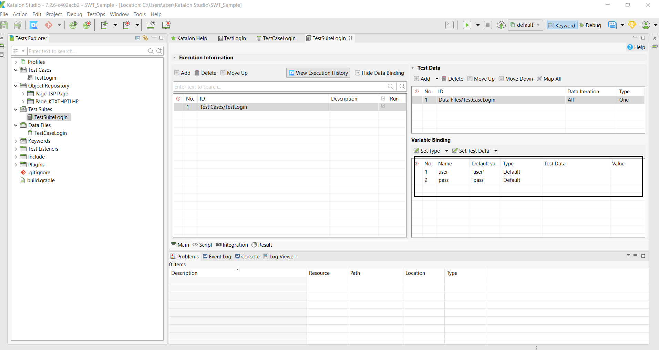

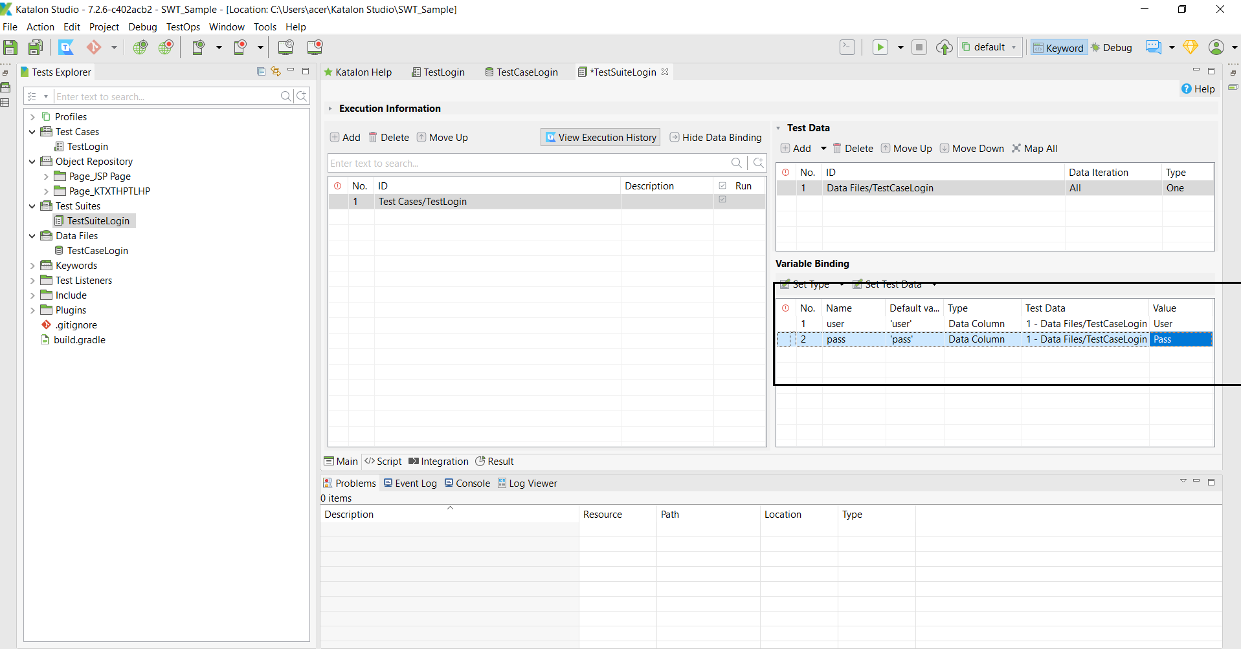

* Test with Chrome

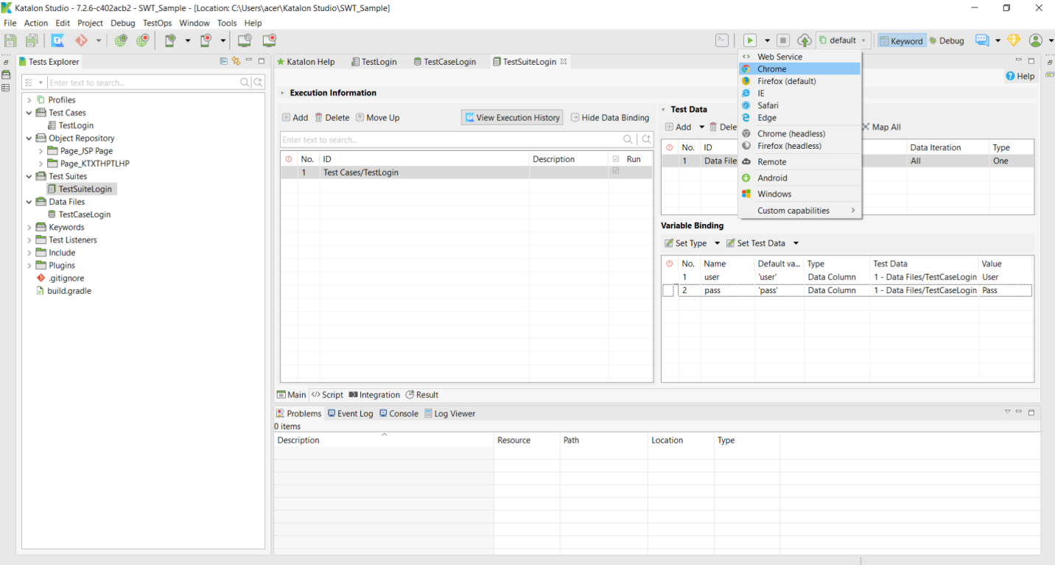

* The software automatically opens web pages and automatically checks the functions

(Autofill account, password and auto login)

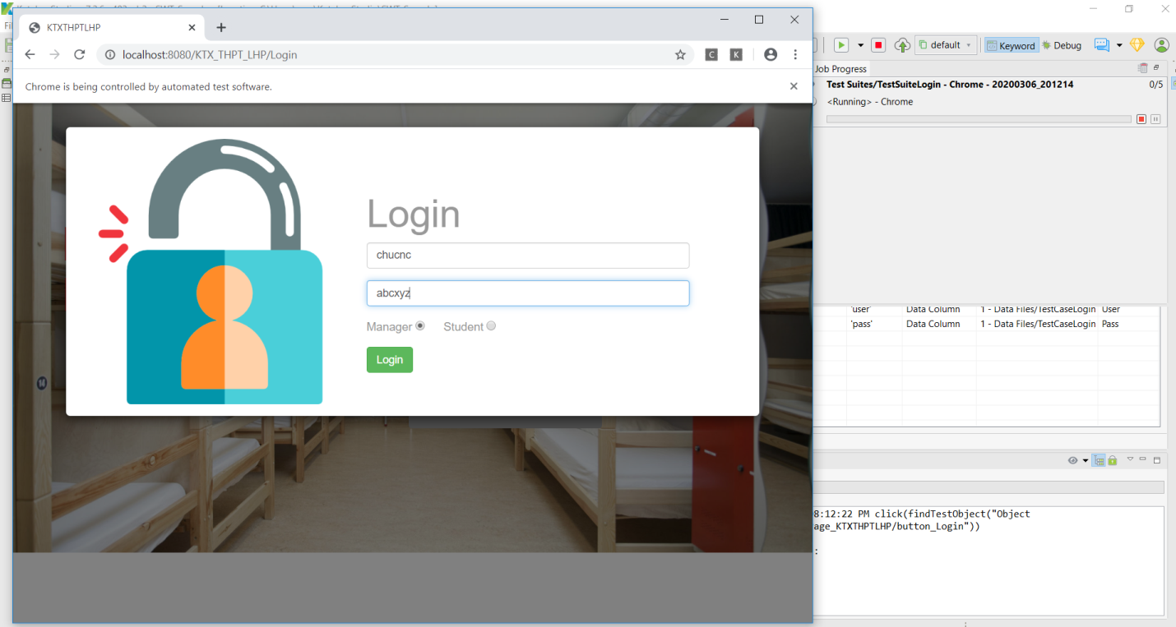

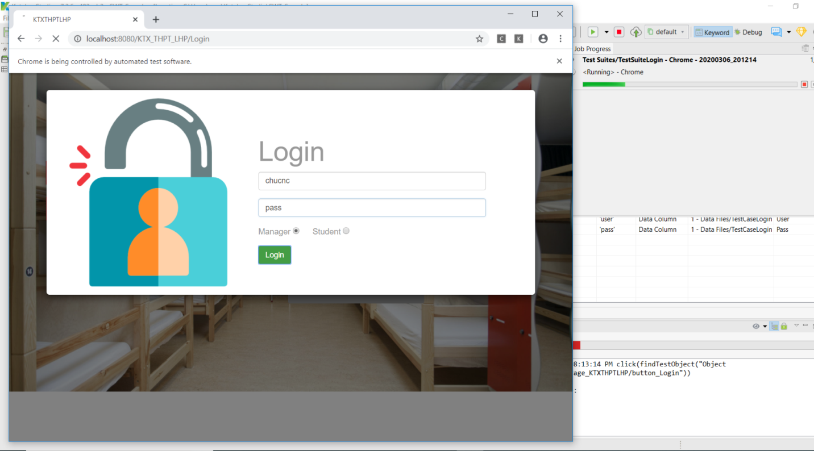

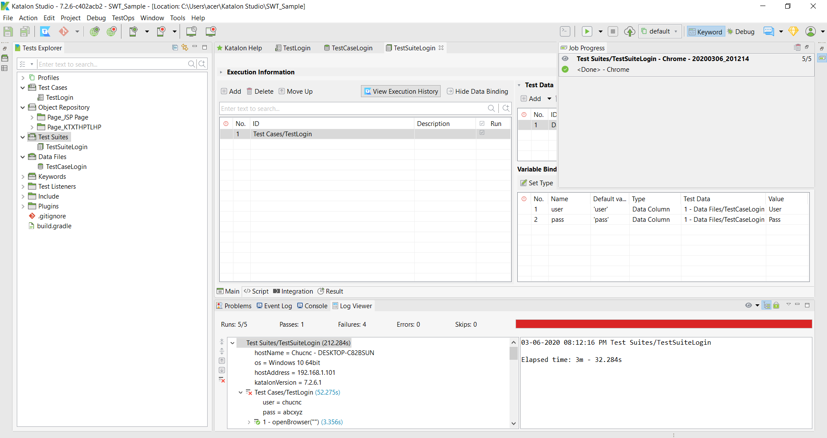

* 4 tests failed :the wrong account, password()1 test passed- the correct account and password

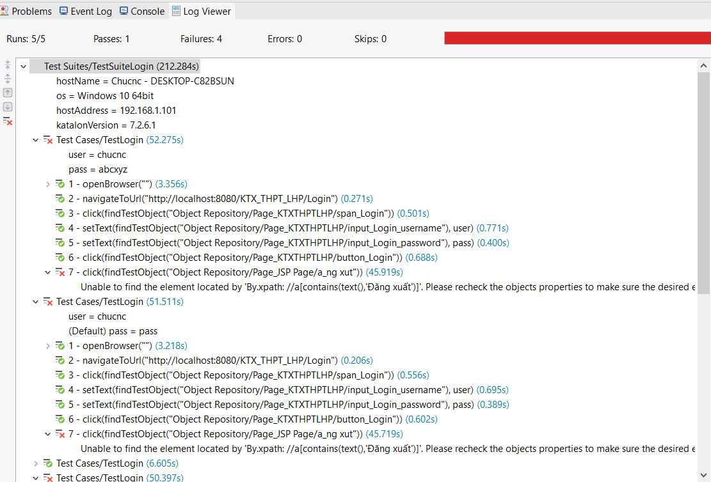

SAMPLE 2: TEST REGISTER HOTEL

